# Appendix A

## Kaiser window comparison for varying alpha.

The figures contained in this appendix show a Kaiser windowed low pass filter impulse response plotted in both the time and frequency domain. The filter parameters: order, sampling frequency, and cut-off frequency were held constant at 30, 8000 Hz, 2000 Hz, respectively. Only the Kaiser parameter alpha was varied in these examples to gauge the way the alpha parameter affects the passband, stopband, and transition response for the filter.

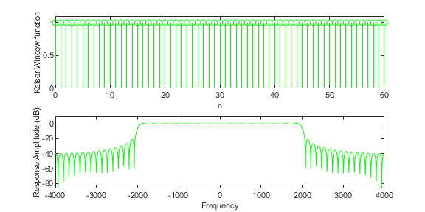

Figure 1: Alpha = 0

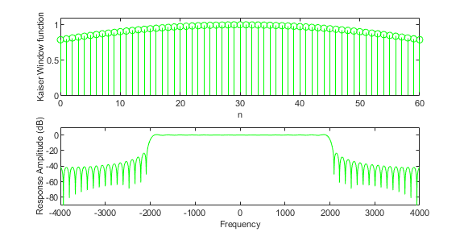

Figure 2: Alpha = 1

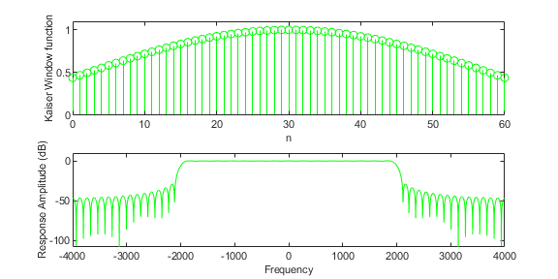

Figure 3: Alpha = 2

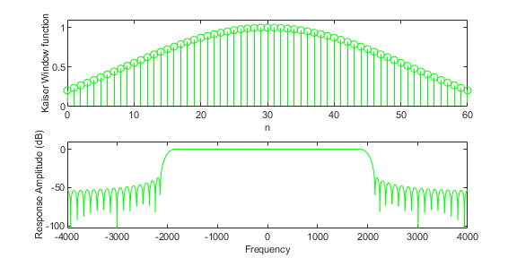

Figure 4: Alpha = 3

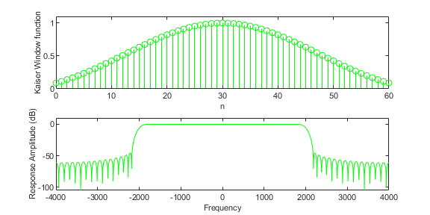

Figure 5: Alpha = 4

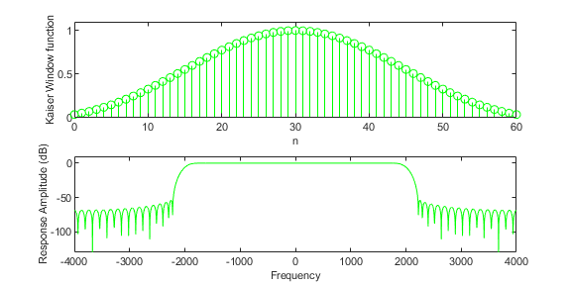

Figure 6: Alpha = 5

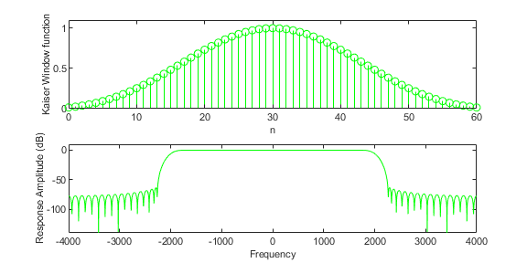

Figure 7: Alpha = 6

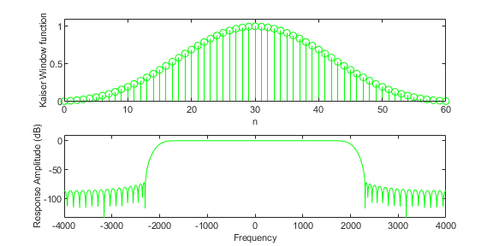

Figure 8: Alpha = 7

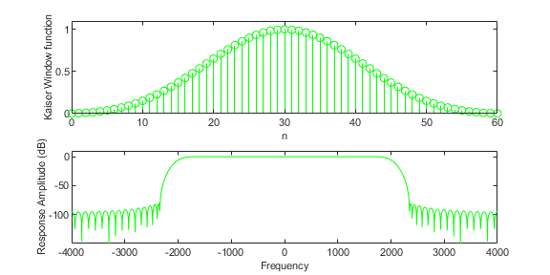

Figure 9: Alpha = 8

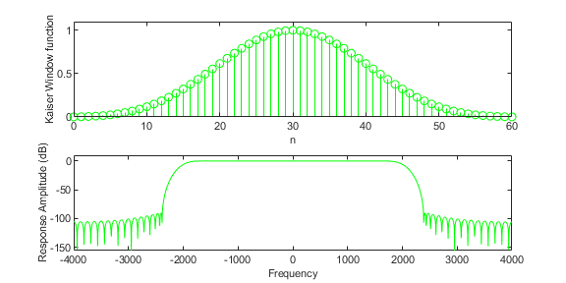

Figure 10: Alpha = 9

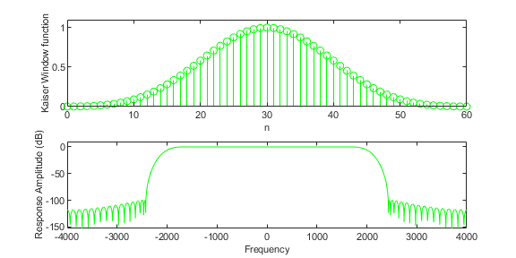

Figure 11: Alpha = 10

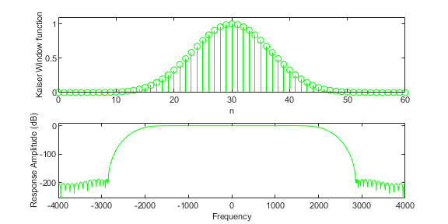

Figure 12: Alpha = 20

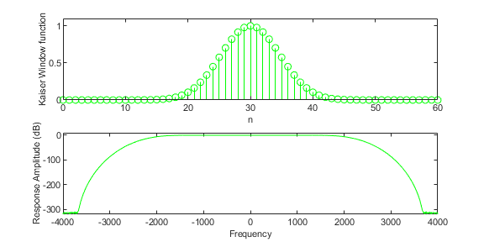

Figure 13: Alpha = 40

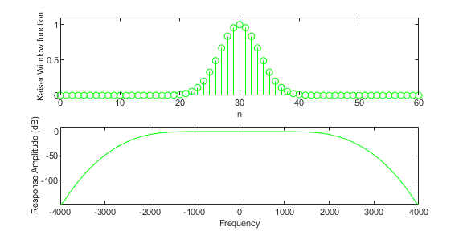

Figure 14: Alpha = 80